**DAILY ASSESSMENT FORMAT**

|  |  |  |  |  |  |
| --- | --- | --- | --- | --- | --- |
| **Course:** | **Machine learning with Python** | |  | **Name:** | Rachana C Hulikatti |
| **Link:** | **https://cognitiveclass.ai/courses** | |  | **USN:** | **4AL17EC108** |
| **Org By :** | **IBM** | |  | **Semester & Section:** | **6-B** |
|  |  |  |  | **Date:** | **16/06/2020** |
|  |

**Progress on 16-06-2020**

* **Topic Completed Today**

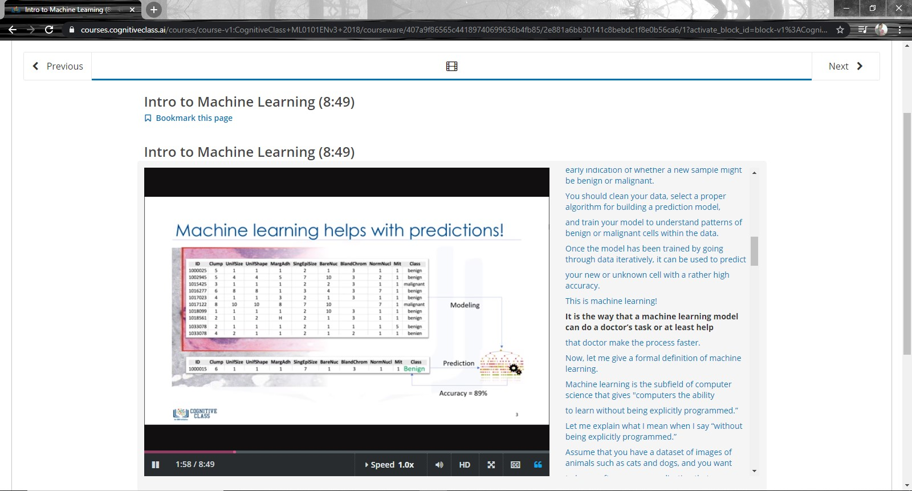

* **Progress Report**

